1.

select customer_id,First_name,Last_name,Address,amount_spent,rank

from (

select dc.customer_id,

dc.cust_first_name as First_name,

dc.cust_last_name as Last_name,

dc.cust_street_address1 as Address,

sum(do.order_total) as amount_spent,

rank() over (order by sum(do.order_total) desc) as rank

from demo_customers dc

inner join demo_orders do on dc.customer_id = do.customer_id

group by dc.customer_id, dc.cust_first_name, dc.cust_last_name, dc.cust_street_address1

)

where

rank <= 3;

2.

select *

from (

select

dc.customer_id,

dc.cust_first_name as First_name,

dc.cust_last_name as Last_name,

dc.cust_street_address1 as Address,

COUNT(do.order_id) as Total_order,

DENSE_RANK() OVER (order by COUNT(do.order_id) desc) as dense_rank

from

demo_customers dc

inner join

demo_orders do on dc.customer_id = do.customer_id

group by

dc.customer_id,

dc.cust_first_name,

dc.cust_last_name,

dc.cust_street_address1

)

where

dense_rank <= 3

order by

Total_order desc;

3.

select *

from (

select

dp.product_id,

dp.product_name,

dp.product_description,

dp.category,

sum(doi.quantity) as Total_quantity_sold,

rank() over (order by sum(doi.quantity) desc) as rank

from

demo_products dp

inner join

demo_order_items doi on dp.product_id = doi.product_id

group by

dp.product_id,

dp.product_name,

dp.product_description,

dp.category

)

where

rank <= 3

order by

Total_quantity_sold desc;

4.

select

dc.cust_last_name as Customer_Last_Name,

dp.product_name as Product_Name,

sum(doi.quantity) as Total_Quantity

from

demo_customers dc

inner join demo_orders do on dc.customer_id = do.customer_id

inner join demo_order_items doi on do.order_id = doi.order_id

inner join demo_products dp on doi.product_id = dp.product_id

group by dc.cust_last_name, dp.product_name

order by product_name;

5.

select *

from (

select

dc.cust_last_name as Customer_Last_Name,

dp.product_name as Product_Name,

sum(doi.quantity) as Total_Quantity

from demo_customers dc

inner join demo_orders do on dc.customer_id = do.customer_id

inner join demo_order_items doi on do.order_id = doi.order_id

inner join demo_products dp on doi.product_id = dp.product_id

group by dc.cust_last_name, dp.product_name

)

PIVOT (

sum(Total_Quantity)

for Product_Name in ('Bag', 'Belt', 'Blouse','Business Shirt','Jacket','Ladies Shoes','Mens Shoes','Skirt','Trousers','Wallet')

);

6.

select order_year,total_orders,most_order_year

from (

select order_year, total_orders,

rank() over (order by total_orders desc) as most_order_year

from (

select

to_char(do.order_timestamp, 'yyyy') as order_year,

count(*) as total_orders

from demo_orders do

group by to_char(do.order_timestamp, 'yyyy')

) ranked_years

)

where

most_order_year = 1;

7.

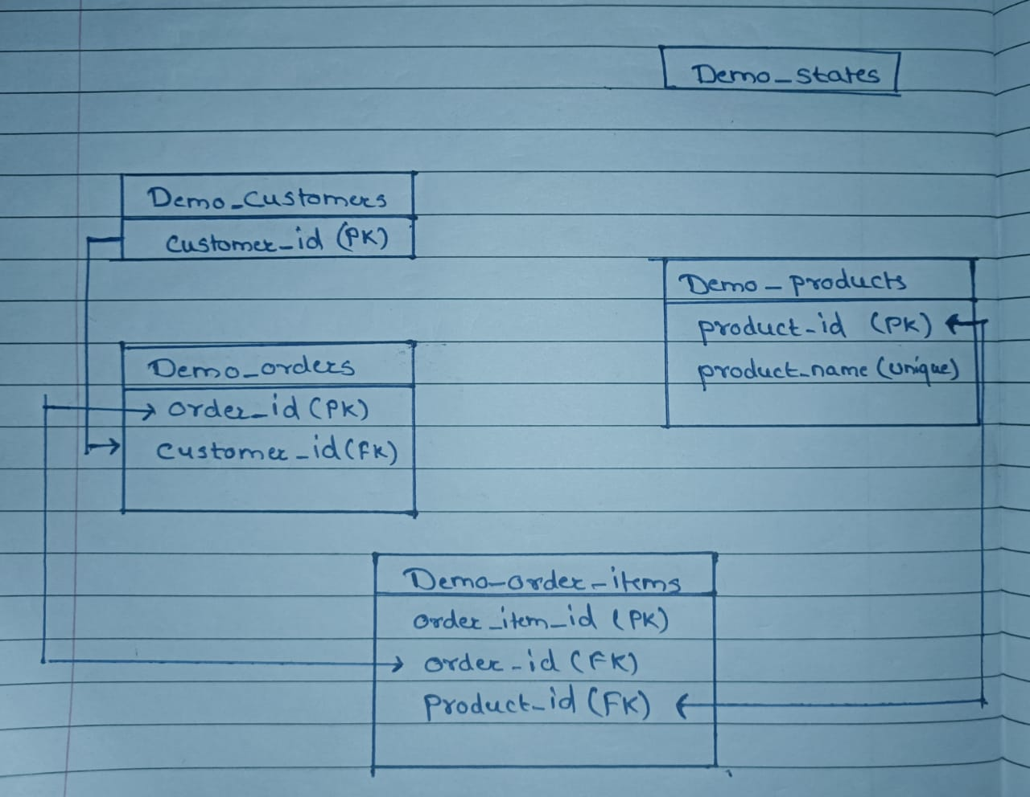

8.

select category, total_quantity_sold, Most_sold_rk_wise

from (

select dp.category,SUM(doi.quantity) as total_quantity_sold,

rank() over (order by sum(doi.quantity) desc) as Most_sold_rk_wise

from demo_products dp

inner join demo_order_items doi on dp.product_id = doi.product_id

group by dp.category

) ranked_categories

where

Most_sold_rk_wise = 1;

9.

select

category,

total_quantity_sold,

rank_category

from (

select

dp.category,

SUM(doi.quantity) as total_quantity_sold,

rank() over (order by SUM(doi.quantity) desc) as rank_category

from demo_products dp

inner join demo_order_items doi ON dp.product_id = doi.product_id

group by dp.category

) ranked_categories

where

rank_category = 2;

10.

select dc.customer_id,

dc.cust_first_name || ' ' || dc.cust_last_name as customer_name,

dp.product_name,

SUM(doi.quantity) as total_quantity

from demo_customers dc

inner join demo_orders do on dc.customer_id = do.customer_id

inner join demo_order_items doi on do.order_id = doi.order_id

inner join demo_products dp on doi.product_id = dp.product_id

group by rollup(dc.customer_id, dc.cust_first_name, dc.cust_last_name, dp.product_name)

order by dc.customer_id, dp.product_name;